**Nuvoton Online Firmware Update Tutorial Series - UART Interface**

Nuvoton's MCU is usually divided into two major blocks, APROM and LDROM. APROM is mainly used to store main applications, while LDROM is used to store ISP program code, which is the bootloader. Nuvoton provides a wealth of ISP reference programs to allow users to get started quickly. The demo UART ISP uses the NuMaker-NUC1262SE V1.1 development board.  
  
1. Download the BSP of NUC1262 from Nuvoton’s Git:<https://github.com/OpenNuvoton/NUC1262BSP>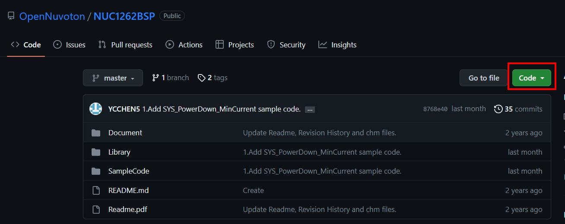

2. Directory NUC1262BSP-master -> SampleCode-> ISP provides a wealth of reference programs. This time we use the ISP_UART sample program.

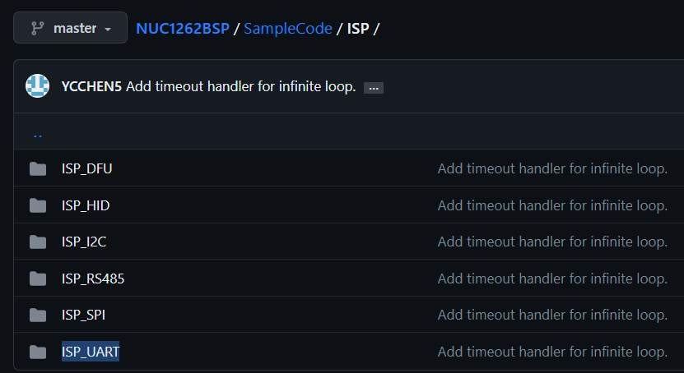

3. Open the program and execute compilation. The program is very simple. If UART ISP intervenes within 300ms after booting, it will enter ISP mode. Otherwise, it will jump to APROM to execute the application.

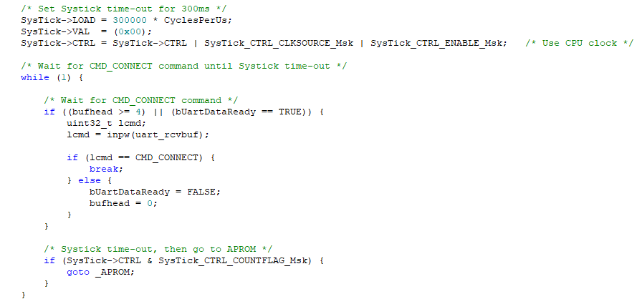

4. Then open[ICP promgramming tool](https://www.nuvoton.com/resource-download.jsp?tp_GUID=SW1720200221181328), load the newly compiled firmware into LDROM, and set LDROM in Config to boot. After confirmation, check LDROM and Config to start burning.

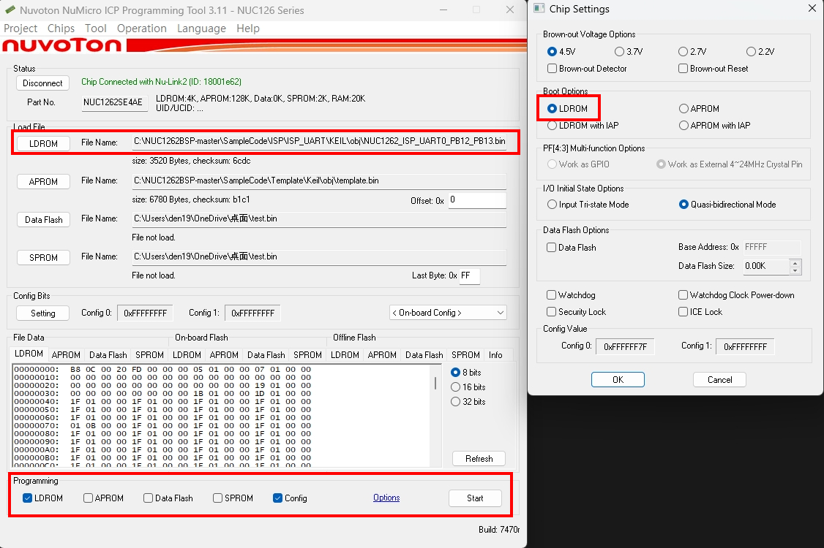

5. Since the Nu-Link2-Me on the development board already contains a set of COM ports, please make sure that the UART of the dip switch on the Nu-Link2-Me is turned on.

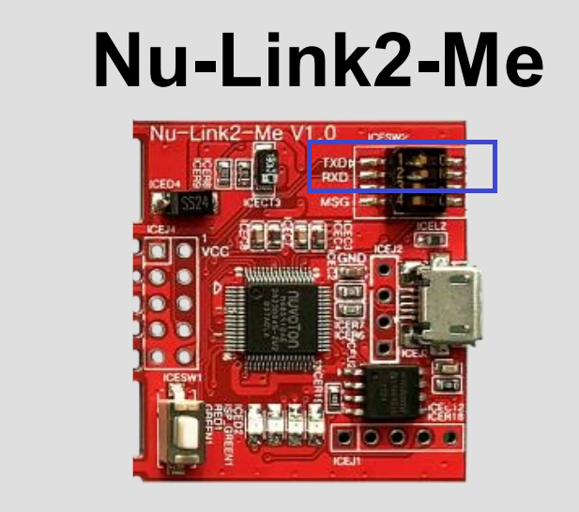

6. Open the ISP programming tool, select the UART and COM port and press Connect. If you cannot connect, press the reset button on the EVB, or check to see if the ICP programming tool is still connected.

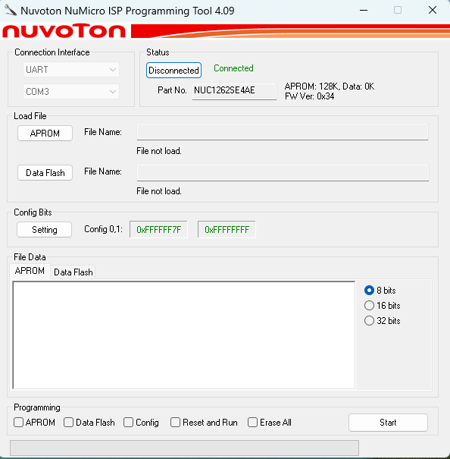

7. Load an application you want to burn into APROM and start burning.

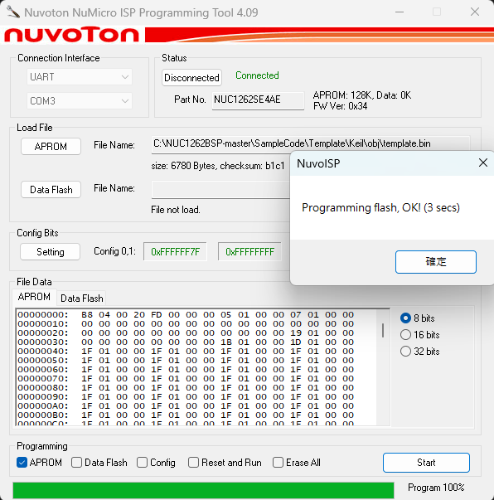

8. Then we can use the ICP programming tool to verify whether the ISP is programmed successfully. Load the APROM code just burned into the ICP programming tool and press refresh. At this time, select the APROM on the chip. The matching data will be displayed on the right, indicating that the programming is successful.

